A000-AM,C-Taino-Cemi-Figure-Marble-1000 CE

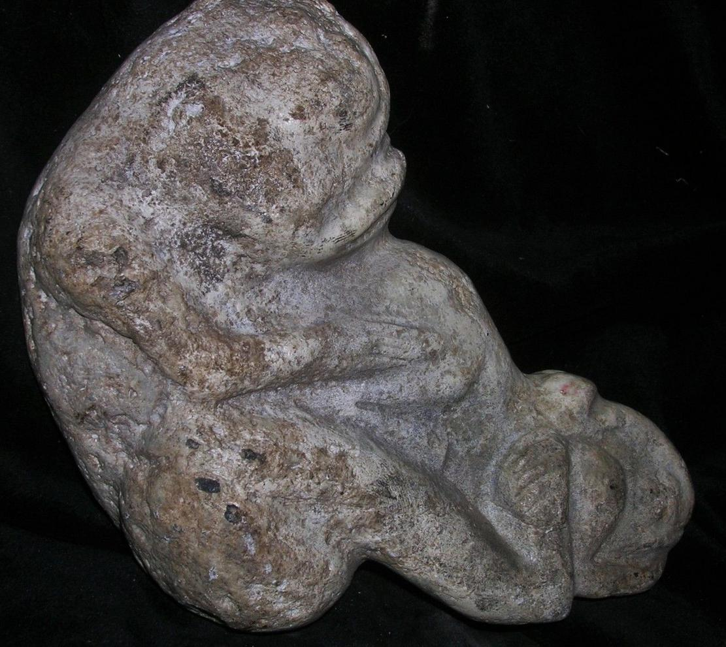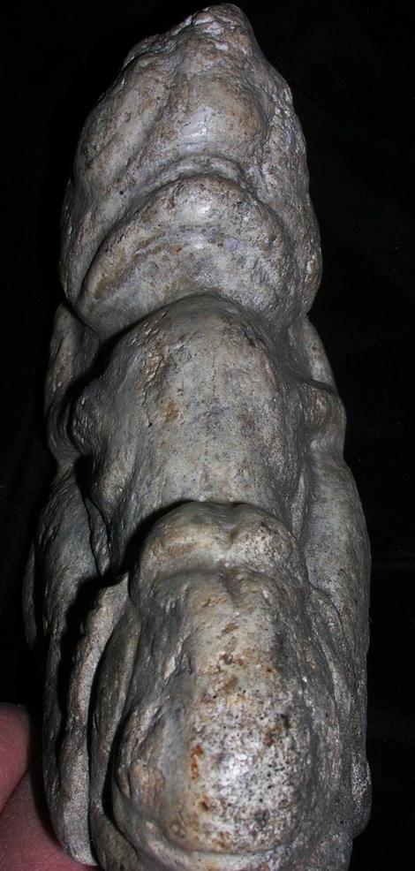

Case No.: 18

**Accession No.**

**Formal Label:** AM,C-Taino-Cemi-Figure-Marble-1000 CE

**Display Description:**

**LC Classification:**

**Date or Time Horizon:**

**Geographical Area:**

**Map:**

**GPS coordinates:**

**Cultural Affiliation:**

**Media:**

**Dimensions:**

**Weight:**

**Condition:**

**Provenance:**

**Discussion:**

**References:**

AUTHENTIC GUARANTEED PRE COLUMBIAN TAINO RITUAL FIGURE, provenance John Therien Estate- New York City date of 6/25/68 Collected on tag, SIMPLY GORGEOUS, NICELY MADE, OLD REPAIRS  ,YEARS OF RITUAL USE-VERY WORN FROM USE

# Order details

## Sales order

Sold by [primitifstuffgal...](http://myworld.ebay.com/primitifstuffgallery) ( [2249](http://feedback.ebay.com/ws/eBayISAPI.dll?ViewFeedback&userid=primitifstuffgallery) )

### Delivery package 1 of 1

Delivered on Monday, Mar 28, 2016

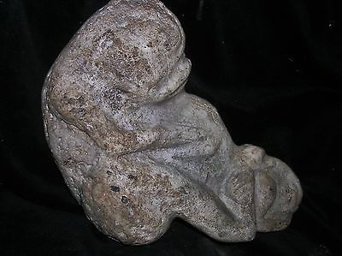

#### [ORIG $399. PRE COLUMBIAN TAINO FIGURE 7➕" PROVENANCE](http://www.ebay.com/itm/222058876885)

|  |  |
| --- | --- |
| Item price | $99.99 |
| Quantity | 1 |
| Item number | 222058876885 |
| Shipping service | USPS Priority Mail |

## Shipping address

Ralph J Coffman Jr

149 Atlantic Ave

Swampscott MA 01907-2427

United States

## Order total

|  |  |
| --- | --- |
| Subtotal | $99.99 |
| Shipping | $10.92 |

**Total**

$110.91

Order placed on

Tuesday, Mar 22, 2016

Payment method

PayPal

Payment date

Tuesday, Mar 22, 2016